**EECS 690**

**Project 2 Report**

**Chen Long**

**KUID: 2774386**

**2018/3/30**

**James Miller**

The first time I use message passing is when rank 0 starts to send each image array to the corresponding rank, I could use MPI_Scatter in this case, but I think if I want to use scatter, then I need an array that holds every image array, this might not be the best way to do it. I use immediate send in a for loop instead because immediate send doesn’t have too much waiting on the send part. You can see that I use immediate send to send the size of the array, but I use blocking receive to receive the size, because I do need to know the size before I start receiving the image array. I use immediate receive because I want to print while rank i starts to receive the image for debugging purpose, I use waitall() to make sure that the receiving part is accomplished.

The second time I use message passing is when each rank is trying to receive all images. There is no doubt that MPI_Allgather is the best option here like what’s shown in figure 1, we will need to use for loop and some other algorithms if we choose to use MPI_Bcast or MPI_Gather, while using MPI_Allgather will be just one line of code, and the implementation is much more efficient in MPI_Allgather().

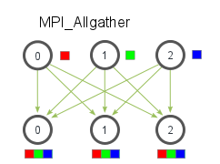

Figure 1

The third time is when all ranks send the result back to rank 0, at this point MPI_Gather is the best solution. All we need is a N size array to store the result and report them.

